Name/Period: ___________________________________ Date: __________

Atomic Matter Guided Notes

What is matter?

What is all matter made of?

Explain how the atomic model has changed over time.

Draw and label the parts of an atom.

Rule for electrons:

How are atoms defined?

Most of the atom’s ___________ is from the _________________ and____________________.

Most of the atom’s _____________________is in the electron cloud.

Most of the atom is ___________ space.

What is an element?

How are elements like the primary colors?

What is the periodic table and how is it organized?

LABEL THE PERIODIC TABLE BOX

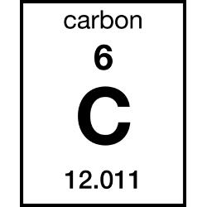
What is valance?
How do elements bond?
What is a covalent bond? Give an example.

What is an ionic bond? Give an example.

Explain the letters in chemical formula. Define the coefficient and subscript of a chemical formula.

Write two examples of a chemical formula and break down how many elements are in each formula.

