Name/Period: __________________________________________________________________

**Carbon Cycle**

What is carbon?

Draw a diagram of carbon.

What makes carbon the primary compound for all living and once living things?

Where can carbon be found?

Do organisms make their own carbon?

The carbon cycle is an __________________ of carbon as it cycles through different

_______________________ and _________________________________ materials.

Carbon can be found in the

Explain carbon cycle equilibrium.

**GEOSPHERE**

Summarize captions below the diagram to explain how coal is formed.

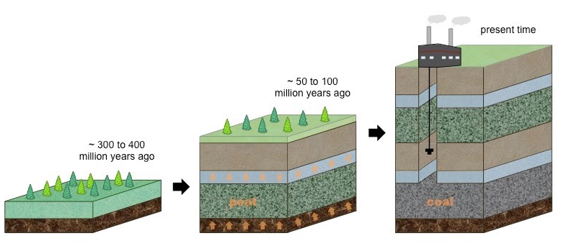

Summarize captions below the diagram to explain how oil and natural gas is formed.

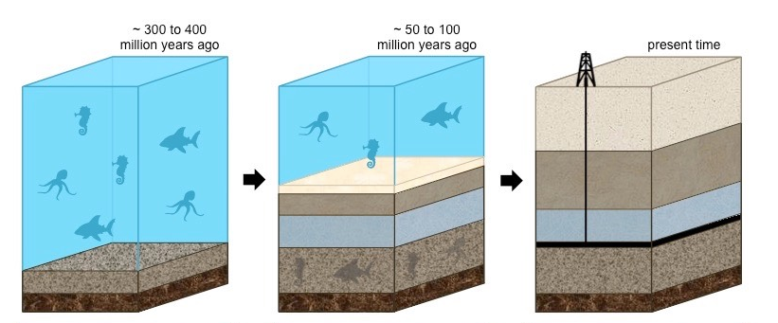

How do fossil fuels become air pollution?

What kind of air pollution is begin created?

Why is this a concern when discussing the carbon cycle?

**HYDROSPHERE**

What is calcium carbonate and how is it formed?

The ocean is the ____________________ active carbon ________________ on Earth.

Some CO2 may remain as dissolved gas within the water, however the majority will combine with water

to form __________________________________________.

The solubility of CO2 gas occurs in _____________________ ocean water.

**BIOSHPERE**

Draw the diagram of photosynthesis and cell respiration.

Explain how decomposition occurs and how it aids in putting carbon back into the carbon cycle.

**CARBON CYCLE**

