Name/Period: _____________________________________
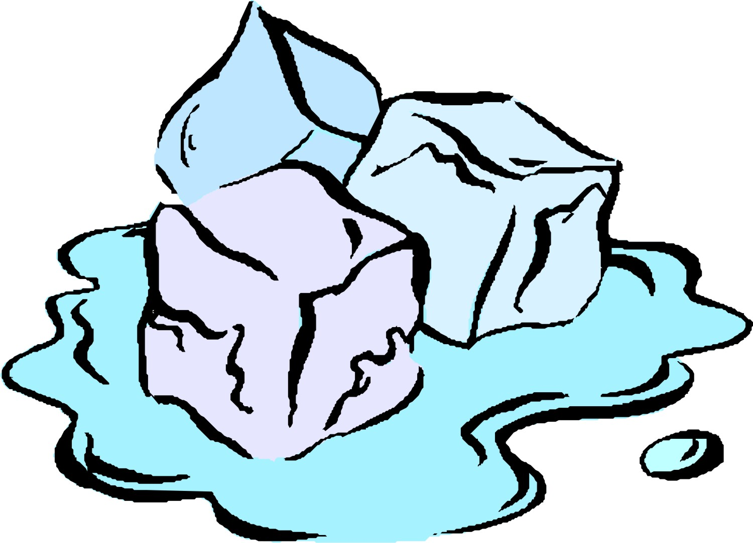
Observation, Inference, and Collecting Data
Isopropyl Alcohol and Ice

Define the following terms

Observation:

Qualitative VS Quantitative

Inference:

PROCEDURES
- As a pair/group collect one clear plastic cup 1/3 full of isopropyl alcohol and one clear cup of ice (5 – 10 cubes approximately)
* Although many of you may have seen similar activities there is much more to observe with this activity. Be observant.
- Decide how you would like to observe adding the ice and alcohol together. Make a prediction before you move on.
- One student will time your observation. Use a class timer or an approved phone.
- Start your timer once you add the ice and alcohol together and time for five minutes. Record your observations as you are timing, keep the timer running.

WRITE A PREDICTION
What do you think will happen to the ice and the alcohol when you add the ice and alcohol together?
OBSERVE AND RECORD
Answer the questions based on your observations.

Initially, What happened when you first added the ice and alcohol together?

After one minute?

After three minutes?

After five minutes?

STOP AT FIVE MINUTES & CLEAN UP.
Pour out the alcohol and ice in the assigned sink. Keep the cups and stack them in the appropriate area.

WHAT HAPPENED AND WHY DID IT HAPPEN?
Use your prior knowledge to answer the questions below and explain what happened.

What happened to the ice?

What happened to the alcohol?

What happened to the cup?

Was anything created from the reaction of the ice and alcohol?

Did you collect any qualitative data?

Did you collect any quantitative data?

Create a question for the class and answer your question based on your observations.

Question:

Answer:
Create a model that explains how the ice and alcohol interacted on an atomic level to create the phenomenon that you observed. Include how heat energy, density, and the states of matter caused this phenomenon.
Draw a diagram, label all drawings, and explain what occurred with arrows, diagrams, and other helpful indicators to explain your model.

