Name/Period: _________________________________________________________

Physical and Chemical Properties of Matter

Go to www.ck12.org and search “Physical Properties of Matter” and click on this was the subhead “definition of physical property and examples of the physical properties of matter.”

From the reading, answer the following questions.

- What is a physical property of matter?

- List three examples of physical properties.

- Compare and contrast the physical properties of chlorinated water and bottled water.

Take the quiz “Practice Physical Properties” at the top of the page.

I scored a ________/10

Go to www.ck12.org and search “Chemical Properties of Matter” and click on this was the subhead “definition of chemical property and examples of the chemical properties of matter.”

- What is a chemical property?

- What is rust and how is it created?

3. Define the chemical property called reactivity.

Take the quiz “Practice Chemical Properties” at the top of the page.

I scored a ________/10
The chart below shows the reactivity of several different metals. The metals range from very reactive to very unreactive. Study the chart and then answer the questions below.
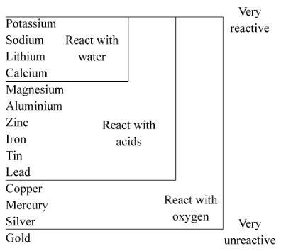

- What is the most reactive metal in the chart?

- What is the least reactive metal?

- Complete this sentence: Only the most reactive metals in the chart react with ______________.

- True or False: Most metals in the chart react with oxygen. __________

- Which of the following metals reacts with oxygen and acids but not with water? Select all that apply.
  - calcium
  - magnesium
  - copper
  - gold
  - zinc

